CUSTOMER ATTRITION ESTIMATE FOR TELCOS
USING MACHINE LEARNING
- JENIFER¹, DR. B. VANI²
Student ¹, Assistant Professor ²,
PG Department of Data Science,
Holy Cross College (Autonomous), Tiruchirappalli.

ACKNOWLEDGEMENT

“Fear of God is the Beginning of Wisdom”
It is a great pleasure to acknowledge with a sincere gratitude to all those who helped to make this project a success. First and foremost, I express my deep sense of gratitude to Almighty God, for His substantial blessings, which includes in unfailing strength, comfort, inspiration and confidence to complete and bring the project to light.
Showing gratitude is not only a courtesy but also duty. I express my respectful and sincere heartfelt thanks to our honourable Secretary Rev. Dr. (Sr.) Annie Xavier M.Sc., M.Phil., Ph.D., and my dynamic Principal, Rev. Dr. (Sr.) Rajakumari, MWS, M.A, M.Phil., Ph.D., Holy Cross College (Autonomous), Tiruchirappalli-2, for providing the opportunity and encouragement to do this course.
I solemnly submit my honest and humble thankfulness to Dr. G. Arockia Sahaya Sheela M.Sc., M.Phil., with SET, B.Ed., MBA., Ph.D., Head & Director –PG Department of Data Science for her guidance, enthusiastic encouragement, and suggestions for this project.
I am very thankful and grateful to my lovable, caring, and respectful Class In-Charge Mrs. M. Sukanya M.Sc., M.Phil., and my project Guide Dr. B. Vani M.Sc., M. Phil., PGDCA., Ph.D. for their patient guidance, encouragement and useful critiques for this project. I would also like to thank them kindness, corrections and encouragement.
Last but not the least I thank everybody who was a source of help to complete this project work effectively. Finally, I am grateful to all who played a role to making this project a success

- JENIFER

ABSTRACT

Customer attrition or churn, is when customers stop doing business with a company. It can have a significant impact on a company's revenue and it's crucial for businesses to find out the reasons why customers are leaving and take steps to reduce the number of customers leaving. One way to do this is by identifying customer segments that are at risk of leaving, and implementing retention strategies to keep them. Also, by using data and machine learning techniques, companies can predict which customers are likely to leave in the future and take actions to keep them before they decide to leave. The dataset used in this study consists of Senior Citizen, Partner, Dependents, tenure, Phone Service, Multiple Lines, Internet Service, Online Security, Online Backup, Device Protection, Tech Support, Streaming TV, Streaming Movies, Contract, Paperless Billing, Payment Method, Monthly Charges, Total Charges, Churn status. Leveraging this dataset, we employ various machine learning algorithms to build a predictive model for customer churn. To address this classification problem, we compare the performance of multiple algorithms such as Logistic Regression, Decision Tree Classifier, Random Forest, Support Vector Classifier and KNN Classifier. Through thorough evaluation and comparison, we identify the most suitable algorithm that provides the highest accuracy and generalizability for customer churn prediction.
Keywords: Telecom churn, Logistic Regression, Decision Tree Classifier, Random Forest, Support Vector Classifier and KNN Classifier.

I. INTRODUCTION

In today's fiercely, retaining is a top priority for sustaining profitability and market relevance. Telco Customer Trades Prediction has emerged as a critical tool to address this challenge. Trades, the loss of to contestants or service termination, can significantly impact a telco company's bottom line. and preventing customer Trades through data-driven has come essential. This project es on the predictive power of data analytics and in the telco sector. We aim to develop accurate that anticipate customer Trades, allowing telecom providers to take proactive measures to retain valuable subscribers. By customer data, usage patterns, and variables, we seek to identify the factors contributing to Trades and predict which clients are most likely to leave.
Our research delves into cutting-edge, feature engineering and progressive procedures, to optimize Trades prediction accuracy. This project's ultimate goal is to equip telco companies with the insights needed to reduce Trades rates, enhance customer satisfaction, and ensure long-term success in a rapidly evolving market.
The telecommunications (telco) industry stands as a cornerstone of modern society, enabling seamless communication and connectivity. However, within the sprawling telco landscape, an ever-persistent challenge looms - customer turnover, colloquially known as "churn." In recent years, this phenomenon has taken center stage in the strategic agendas of telco providers, for it poses a significant threat to their sustainability and profitability. This introduction delves into the theoretical underpinnings of customer turnover in the telco sector, illuminating the crucial context for the subsequent project.
  - The Dynamics of the Telco Industry
The telecommunications (telco) industry is a dynamic and ever-evolving sector, where technological advancements, changing market forces, and evolving consumer demands continually shape the landscape. Amidst fierce competition among multiple service providers, the industry faces the challenges of customer churn, making it a formidable adversary that can erode market share, revenue, and profitability. Factors such as mobile number portability, regulatory changes, and the emergence of 5G technology have heightened the battle for customer loyalty, emphasizing the need for telco companies to remain innovative and customer-focused. To thrive in this environment, telco firms must adapt swiftly, leveraging cutting-edge technologies and customer-centric strategies to retain and attract subscribers, ultimately securing their position in this fast-paced and dynamic industry.
1.2 Understanding Customer Churn
Customer churn, simply put, refers to the phenomenon where customers terminate their subscriptions or switch to a different telco provider. This attrition is often triggered by a myriad of factors, including but not limited to:
- Service Quality: In today's highly competitive telecommunications industry, customer expectations for top-notch service quality are paramount. Consumers demand nothing less than seamless connectivity and high-quality services, and any deviations from this standard can swiftly result in dissatisfaction and, consequently, customer churn. In an era where connectivity is the lifeblood of modern society, network disruptions, sluggish data speeds, or unreliable coverage can disrupt daily routines, hinder productivity, and frustrate customers. Telco providers must maintain robust and resilient networks, invest in infrastructure, and continually improve service quality to meet these expectations. Failing to deliver on these fronts not only risks customer attrition but also damages a company's reputation and competitiveness in a market where service excellence is a non-negotiable requirement.
- Price Sensitivity: In the fiercely competitive landscape of the telecommunications industry, price sensitivity is a pervasive and potent factor that significantly influences customer behavior. With numerous providers vying for their business, customers have become increasingly attuned to cost considerations. This heightened price sensitivity prompts consumers to frequently explore alternative providers in pursuit of better deals, cost savings, or more attractive pricing plans. The ease of switching in today's market, often facilitated by mobile number portability, means that customer loyalty is more tenuous than ever. Telco companies must continuously balance the need for competitive pricing with the imperative to maintain profitability and invest in infrastructure and innovation, making pricing strategy a pivotal element in their efforts to retain and attract customers in this highly dynamic and cost-conscious environment.
- Customer Service: The role of customer service cannot be overstated, as it wields a considerable influence on customer retention and satisfaction. Poor customer service experiences, characterized by lengthy wait times, unresolved issues, or unhelpful support, can swiftly drive customers away. In an era where communication is a lifeline for both personal and professional purposes, customers expect responsive, efficient, and effective support. Disappointments in this regard not only lead to frustration but also erode trust in a service provider. With numerous alternatives available in the market, dissatisfied customers are increasingly inclined to explore other options. Recognizing the critical importance of customer service, telco companies must invest in robust support systems, effective training for their staff, and streamlined issue resolution processes to ensure that customer interactions are positive, ultimately securing their loyalty and trust in an industry where service quality is pivotal to success
- Contract Terms: In the dynamic world of telecommunications, contract terms play a pivotal role in customer retention. Expiring contracts or unfavorable terms can be strong motivators for customers to explore alternative service providers. With the rapid evolution of technology and shifting market dynamics, consumers are often seeking more flexibility and improved terms in their telecommunications agreements. If existing contracts are perceived as restrictive, costly, or simply no longer aligned with their needs, customers are inclined to search for better options that offer competitive pricing, adaptable terms, and value-added benefits. To mitigate the risk of customer churn, telco companies must regularly reassess and adapt their contract offerings to meet the evolving demands and expectations of their customers, ensuring that their agreements remain attractive and aligned with the ever-changing landscape of the industry.
1.3 The Imperative of Predictive Analytics
Traditionally, telco providers have responded to churn reactively, attempting to win back customers after they have already decided to leave. However, this approach is fraught with challenges, including the cost and uncertainty of reacquisition. As such, the industry has shifted towards a proactive strategy that relies on predictive analytics and machine learning to forecast customer turnover.
1.4 Project Rationale
The rationale for this project is rooted in the imperative for telco providers to proactively address customer churn. By developing predictive models that can anticipate churn indicators, telco companies can intervene before customers decide to switch providers. Such proactive interventions can encompass targeted marketing campaigns, personalized offers, or improvements in customer service, thereby mitigating churn and preserving customer relationships.
1.5 The Significance of Predicting Customer Turnover
The significance of predicting customer turnover in the telco industry extends beyond mere cost reduction. It encompasses several key facets:
- Financial Stability: Achieving and maintaining financial stability is intricately linked to customer retention. Reduced churn rates, the ability to keep customers loyal and satisfied, directly translate into higher customer retention, which, in turn, bolsters revenue and profitability. When customers stay with a telco provider over the long term, they generate a consistent stream of revenue through subscription fees and additional services. This stability provides the company with a more predictable financial outlook and allows for greater investment in infrastructure, innovation, and improving service quality. Moreover, satisfied, loyal customers often become brand advocates, further attracting new business. Thus, financial stability is not only a result of low churn rates but also a fundamental enabler for continued success in the competitive telco market, creating a positive feedback loop that reinforces a company's position and prosperity.
- Competitive Edge: In the dynamic landscape of the telecommunications industry, having churn prediction models at their disposal equips telco providers with a formidable competitive edge. These predictive models enable companies to anticipate and understand customer behavior, empowering them to offer tailored solutions and proactive measures aimed at retaining customers effectively. By identifying potential churners in advance, providers can engage in personalized communication, address specific pain points, and offer incentives or services that resonate with individual customers, thereby fostering loyalty. This not only helps in preserving their existing customer base but also minimizes the costly and resource-intensive process of acquiring new customers. In a market where customer retention is paramount, churn prediction models not only give telco providers a strategic advantage but also contribute to sustaining long-term profitability and growth in the face of intense competition.
- Customer-Centricity: Predictive models enable telco companies to enhance the overall customer experience by addressing issues and concerns before they result in churn, fostering loyalty and satisfaction.
- Resource Optimization: Resource optimization is a critical aspect of the telecommunications industry's operational efficiency, and churn prediction models play a pivotal role in this endeavor. These models allow telco providers to precisely target their retention efforts towards high-risk customers, thereby streamlining the allocation of resources. By identifying those at greatest risk of churning, providers can focus their marketing campaigns, customer support initiatives, and incentive programs on the most relevant segments, making their efforts more cost-effective and efficient. This not only conserves valuable resources but also ensures that the right interventions are deployed to retain the customers who are most likely to leave. Consequently, this approach not only enhances profitability by reducing customer loss but also enables telco companies to operate with greater financial prudence, a critical factor in an industry characterized by intense competition and evolving consumer demands.
In summary, this project embarks on the journey of addressing the pervasive issue of customer turnover in the telco sector by delving into predictive analytics and machine learning. The theoretical backdrop elucidated in this introduction sets the stage for a comprehensive exploration of how data-driven insights can empower telco providers to reduce churn rates, elevate customer satisfaction, and secure their competitive standing in an ever-evolving industry. The subsequent chapters will delve into the practical aspects of data collection, model development, and implementation, providing a roadmap for achieving these critical objectives.

II. LITERATURE SURVEY

Hamdullah Karamollaoglu et al [1]: The work in this paper is focusing on Machine learning techniques used in Customer Churn Prediction like Logistic Regression, K-Nearest Neighbor, Decision Trees, Random Forest, Support Vector Machines, AdaBoost, Multi-Layer Sensors, and Naive Bayes approaches were applied to the required datasets in the analytical process. The Random Forest method proved to be the most effective approach in the customer loss analysis carried out on both datasets.

Abhishek Gaur [2]: In this study, four machine learning models—Logistic Regression, SVM, Random Forest, and Gradient Boosted Tree—were trained. Of these, Gradient Boosting performed the best, while Logistic Regression and Random Forest were average and SVM was the least effective of the four.
Momin, S., Bohra, T. and Raut [3]: In order to predict customer turnover on IBM's Telco Customer turnover dataset, this chapter includes an experimental comparison of several conventional classification techniques, including K-nearest neighbors, naive Bayes, random forest, decision tree, and logistic regression, with artificial neural networks. Based on how well these models foresee client attrition, we have compared them. On validation data, our ANN model performs better than our performance of 79.86% for the conventional strategy of utilizing K-nearest neighbors, achieving an accuracy score of 82.83%. According to the results, multilayered ANN models that can learn on their own and accept tokenized data perform better than conventional classification methods.
Abhishek Gaur; Ratnesh Dubey [4]: The focus of this work is on different machine learning methods for predicting customer churn. Using these methods, classification models may be built using techniques like Logistic Regression, SVM, Random Forest, and Gradient Boosted Tree.
T. Vafeiadis et al [5]: These results show that the boosted versions of the models are clearly superior to the ordinary (non-boosted) counterparts. The SVM-POLY employing AdaBoost was the best overall classifier, with an F-measure of over 84% and accuracy of approximately 97%.
Fan, J., Zhang, J.et al [6]: These results show that the boosted versions of the models are clearly superior to the ordinary (non-boosted) counterparts. The SVM-POLY employing AdaBoost was the best overall classifier, with an F-measure of over 84% and accuracy of approximately 97%.
Aayushi Gandhi[7]: In order to forecast telecom customer turnover, machine learning and deep learning techniques are investigated in this study. To predict whether a client will leave or stay, widely used methods like Random Forest Classifiers and SVMs are contrasted with somewhat more recent structures like XG Boost and Deep Neural networks. By running these models via a grid search, the effectiveness of the models is further investigated. From this experiment, it can be concluded that the Random Forest model, which has a prediction accuracy of 90.96% on the testing data prior to grid search, performs the best for this specific use case.

III. PROBLEM STATEMENT

"In today's fiercely competitive telecommunications industry, retaining customers and reducing churn rates are paramount for telecom service providers. Customer churn, defined as the phenomenon where customers choose to terminate their subscriptions and leave the telecom industry altogether, poses a significant challenge. Telecom companies face the risk of not only losing revenue from departing customers but also struggling to sustain growth and profitability. The primary problem to be addressed in this project is the prediction of customer churn within the telecom industry. Specifically, the objective is to develop accurate and actionable predictive models that can identify customers at risk of leaving the telecom industry. By doing so, telecom companies can take proactive measures to retain these customers, enhance their overall experience, and, ultimately, mitigate the adverse effects of industry attrition.

IV. METHODOLOGY

4.1 Data Set
The data set is the foundation for everything, and it must contain complete facts to enable the machine to learn about the issue. Datasets can be created or constructed using the discarded information found online. Some challenges include building a dataset that makes sense and provides guidance on how to respond based on the problem's real-time inputs. Every day, data can be acquired via the internet. Data are gathered into datasets. A data set typically consists of a single database table or statistical data matrix, where each row corresponds to a specific member of the data set in question and each column defines a specific variable. Values are listed in the data set.

4.2 Data Collection:
Gather historical customer data from your telecom database, including customer demographics, usage patterns, contract details, billing information, customer service interactions, and any other relevant information.
Ensure the dataset includes both churned (customers who left) and retained (customers who stayed) records for model training.
4.3 Data Cleaning:
Handling Missing Data: Identify and address missing values. Options include removing rows with missing values, imputing missing values using appropriate methods, or flagging missing values for further consideration.
Handling Duplicates: Check for and remove duplicate records to maintain data integrity.
Outlier Detection and Treatment: Identify outliers in numerical features and decide whether to cap/extreme value replacement or remove extreme values.
Handling Categorical Variables: Encode categorical variables using techniques like one-hot encoding or label encoding.
Normalization/Standardization: Normalize or standardize numerical features to ensure consistent scales.
Balancing Imbalanced Data: If there's a class imbalance between churned and retained customers, consider oversampling the minority class or under sampling the majority class to balance the dataset.
Feature Engineering: Create new features or modify existing ones to capture meaningful information for churn prediction. This could include calculating customer tenure, deriving usage trends, or creating aggregate statistics.
Validation of Data Consistency: Ensure data consistency and accuracy by validating against business rules and common-sense logic.
Handling Anomalies: Detect and address anomalies or data entry errors that may affect the quality of the dataset.
Data Transformation: Apply appropriate transformations to the data, such as logarithmic transformations, to make it suitable for modeling.
4.4 Data Preprocessing:
Data preprocessing in telco customer churn prediction refers to the set of tasks and techniques applied to the raw telecommunications customer data before it is used for analysis or machine learning modeling. This process involves cleaning, transforming, and organizing the data to ensure it is accurate, complete, and suitable for predictive modeling. Data preprocessing aims to enhance the quality of the dataset, making it more effective for identifying patterns and predicting customer churn accurately.
Common data preprocessing steps in this context include handling missing values, encoding categorical variables, scaling numerical features, and addressing outliers, among others. The ultimate goal of data preprocessing is to prepare the data so that machine learning algorithms can be applied effectively to predict customer churn and assist telecom companies in customer retention efforts.
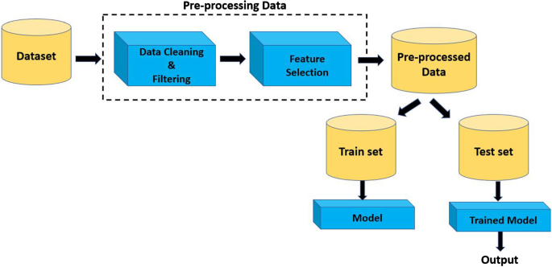
Feature Selection: Select the most relevant features for churn prediction based on domain knowledge and feature importance analysis.
Data Splitting: Divide the dataset into training, validation, and test sets. A typical split may be 70% for training, 15% for validation, and 15% for testing.
Scaling Features: Normalize or standardize features as required, particularly for algorithms sensitive to feature scales.
Handling Time-Series Data: If time-series data is available, consider time-based features and data splitting strategies that preserve chronological order.

4.5 Logistic Regression
Logistic Regression is a statistical and machine learning model used for binary classification tasks, where the goal is to predict one of two possible outcomes or classes, typically denoted as 0 and 1. It is named "logistic" because it utilizes the logistic function, also known as the sigmoid function, to model the probability that a given input belongs to one of the two classes. In logistic regression, the model calculates the odds or likelihood of the event occurring and maps this to a value between 0 and 1. This probability is then used to make predictions, typically with a threshold of 0.5; values greater than the threshold are classified as one class, while values less than the threshold are classified as the other. Logistic regression is widely used in various fields, including healthcare, finance, and marketing, for tasks like spam detection, credit scoring, and medical diagnosis, among others.
4.6 Support Vector Classifier
A Support Vector Classifier (SVC), also known as a Support Vector Machine (SVM) with a linear kernel, is a supervised machine learning algorithm used for classification tasks. It belongs to the family of discriminative models and is particularly effective in binary classification, where the goal is to separate data points into two classes or categories. The SVC works by finding a hyperplane that maximizes the margin of separation between the two classes in the feature space. This hyperplane is selected in such a way that it is closest to some data points from each class, called support vectors. SVC can handle both linearly separable and non-linearly separable datasets through the use of various kernel functions, which transform the data into a higher-dimensional space to enable separation. The primary objective of an SVC is to find the optimal hyperplane that not only separates the data but also generalizes well to classify new, unseen data accurately. SVCs are widely used in a range of applications, including image classification, text classification, and, in the context of churn prediction, to classify customers as churners or non-churners based on their features and behaviors.
4.7 Decision Tree Classifier
A Decision Tree Classifier is a supervised machine learning algorithm used for both classification and regression tasks. It creates a tree-like model of decisions and their possible consequences. In the context of classification, it is designed to predict the class or category of a given input by recursively splitting the dataset into subsets based on the values of input features. At each internal node of the tree, a decision or test is made on a feature, and the data is partitioned into branches that correspond to different outcomes of the test. The process continues until a leaf node is reached, which represents the predicted class label. Decision trees are interpretable, easy to visualize, and are widely used for tasks like customer churn prediction, spam detection, and medical diagnosis, among others.
4.8 KNN Classifier

The k-Nearest Neighbors (KNN) Classifier is a supervised machine learning algorithm used for classification tasks. In KNN, an object is classified by a majority vote of its neighbors, with the object being assigned to the class most common among its k-nearest neighbors. It operates on the principle of similarity, where data points that are closer to each other in feature space are more likely to belong to the same class. KNN does not make assumptions about the underlying data distribution, making it a non-parametric and versatile algorithm. It is commonly used for tasks like pattern recognition, image classification, and recommendation systems, where the relationship between data points can be inferred from their proximity in the feature space. The choice of the parameter k (the number of neighbors to consider) can significantly impact the algorithm's performance and generalization.

V. IMPLEMENTATION

5.1 Importing Dataset
Importing a dataset for telco, or telecommunications, data analysis involves the process of loading and incorporating the relevant data into your analysis environment, typically a software or programming tool like Python, R, or a spreadsheet program. This step is essential as it provides the foundation for all subsequent data exploration, cleaning, and modeling tasks in telco-related projects. The dataset typically contains information about customers, their usage patterns, billing details, customer service interactions, and whether they have churned or not. By importing the telco dataset, analysts and data scientists gain access to the raw data required for predictive modeling and business insights, enabling them to uncover patterns, trends, and valuable information that can help telecom companies optimize customer retention strategies and make data-driven decisions.
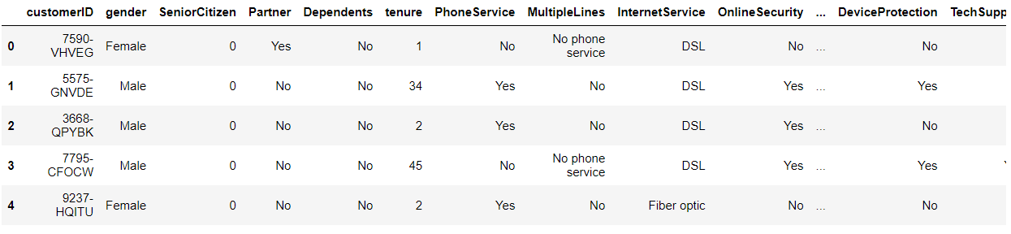
Figure:1 Importing Dataset

The dataset contains categorical (two or more values without any sort of order) and numerical features. Except for: Most feature titles are self-explanatory.

Partner: whether or not the client has a partner (Yes, No);

Dependents: Whether the client is supported by dependents (Yes, No);

Online Backup: the number of months the customer has been a customer of the company,

tenure: whether the customer has online backup (Yes, No, or No internet service),

Total Charges is the entire amount charged to the consumer, whereas Monthly Charges is the monthly fee to the customer.

The dataset contains 7043 customers and 19 features without the non-informative customerID and the target variable's churn column. Most category characteristics have four or fewer distinct values.

5.2 Exploratory Data Analysis

Exploratory Data Analysis (EDA) for a telco dataset involves the systematic process of visualizing, summarizing, and understanding the key characteristics and patterns within the data. It aims to uncover valuable insights that can inform subsequent analyses and modeling efforts for tasks like customer churn prediction. During EDA, analysts examine various aspects of the telco data, such as customer demographics, usage behavior, billing information, and more. They employ techniques like data visualization, statistical summaries, and correlation analysis to identify trends, anomalies, and potential relationships between variables. EDA not only helps in identifying important features for modeling but also assists in addressing data quality issues, missing values, and outliers, ensuring that the data is well-prepared for accurate predictive modeling and actionable business insights within the telecommunications industry.

5.3 Feature distribution

To look for outliers and compare feature distributions with the goal variable, we plot distributions for both numerical and categorical characteristics.

Numerical features distribution
The use of numerical summarizing approaches (mean, standard deviation, etc.) makes it difficult to spot outliers because they don't display distributional spikes or forms. That is why we employ histograms.
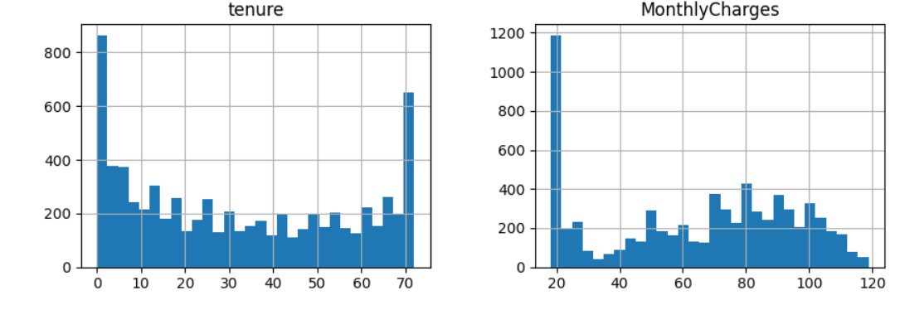
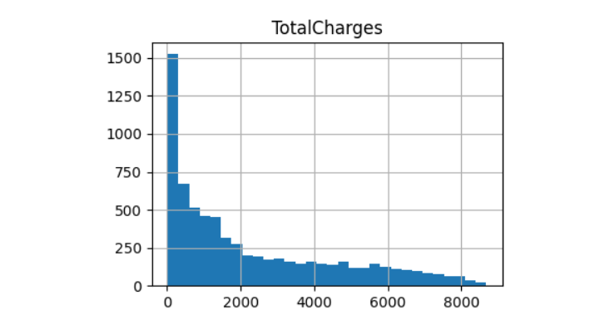

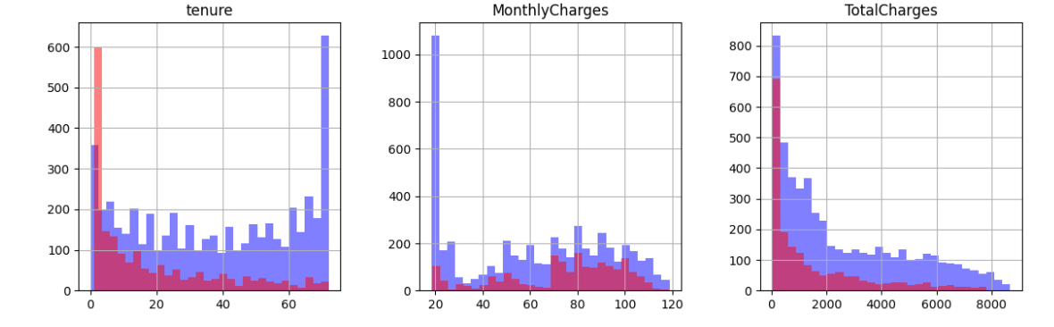
Figure2: Numerical features distribution

Categorical feature distribution

Categorical feature distribution in telco customer churn prediction refers to the pattern or spread of non-numeric attributes (e.g., customer gender, subscription plan, contract type) within the dataset. It involves understanding how these categorical variables are distributed across different categories or classes, which is crucial for identifying potential factors influencing customer churn and for creating effective predictive models. Analyzing categorical feature distribution helps in recognizing trends and relationships that may impact customer behavior and informs feature engineering and selection processes in churn prediction models.
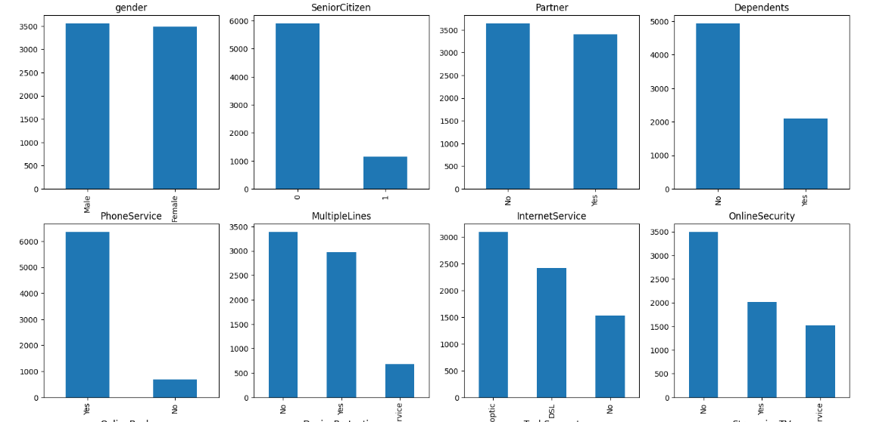

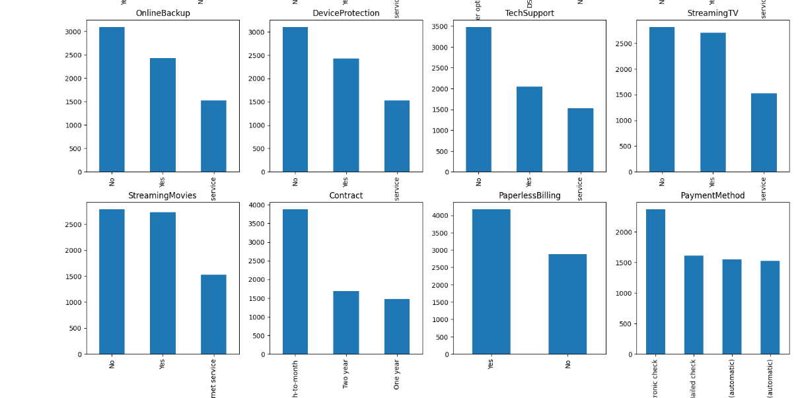
Figure:3 Categorical feature distribution
Target variable distribution
Target variable distribution reveals that there are significantly more non-churned users than churned users, indicating that the problem we are facing is uneven. The model would achieve high accuracy because it would mostly anticipate users in the majority class—those who, in our case, did not churn.
There are a few things we can take to lessen the impact of an unbalanced dataset:
- Re-sample the data,
- get additional samples,
- utilize recall and precision as criteria for accuracy.
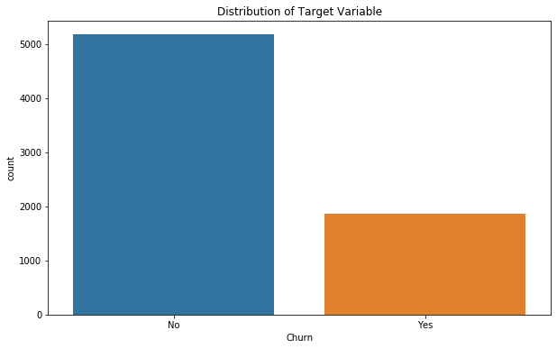
Figure:4 Target variable distribution

5.4 Outliers Analysis with IQR Method:

Outliers analysis using the Interquartile Range (IQR) method in telco customer churn prediction is a vital component of the project methodology. In this context, outliers are data points that deviate significantly from the typical patterns within the dataset, and identifying them is crucial for ensuring the accuracy and robustness of predictive models. The IQR method involves calculating the interquartile range, which represents the spread of data between the first quartile (25th percentile) and the third quartile (75th percentile) of a variable's distribution. Data points lying below the lower bound (Q1 - 1.5 * IQR) or above the upper bound (Q3 + 1.5 * IQR) are considered outliers. By applying the IQR method, we can systematically detect and potentially address outliers in telco customer data, which may include anomalies in usage patterns, billing information, or other variables.
This process enhances the quality and reliability of the data used for subsequent analysis and model building, ultimately contributing to more accurate and actionable insights for churn prediction.

5.6 Feature scaling
Feature scaling in telco customer churn prediction refers to the process of standardizing or normalizing the numerical features within the dataset to ensure they have similar scales or units. This is done to prevent certain features from dominating the modeling process due to their larger magnitude, making it fair for all features to contribute equally to the predictive model. Common methods include Min-Max scaling (scaling features to a specified range, typically [0, 1]) and z-score standardization (scaling features to have a mean of 0 and a standard deviation of 1). Feature scaling is essential to enhance the performance of machine learning algorithms and improve the accuracy of churn prediction models.

5.7 Feature Selection

Feature selection in telco customer churn prediction is the process of choosing a subset of the most relevant and informative features (variables or attributes) from the available data. It aims to improve model performance, reduce overfitting, and enhance model interpretability by retaining only those features that have a significant impact on predicting customer churn while discarding irrelevant or redundant ones. This selection of relevant features helps streamline the modeling process, making it more efficient and effective in identifying patterns and trends associated with customer churn.

5.8 Prediction using Logistic Regression

We can forecast the likelihood of churn, or the likelihood that a client would terminate their membership, using logistic regression. A supervised learning approach used for categorization is logistic regression. We establish a threshold in logistic regression; only the classification is performed using this method depending on the limit. The classification problem itself determines the threshold value, which is a variable.
The principal categories of qualities are:
- Demographics, such as age and gender
- Services used (e.g., internet packs bought, special offers used).
- Expenses (such as the monthly recharge rate, etc.)
You want to create a model that can forecast whether or not a specific client would churn based on all of this historical data.
The variable "Churn" will therefore tell us whether or not a specific client has churned, making it the target variable in this situation. It is a binary variable where 1 indicates that a customer has left and 0 indicates that they have not. We need to forecast if a specific customer will migrate to another telecom provider or not using 21 predictor variables.
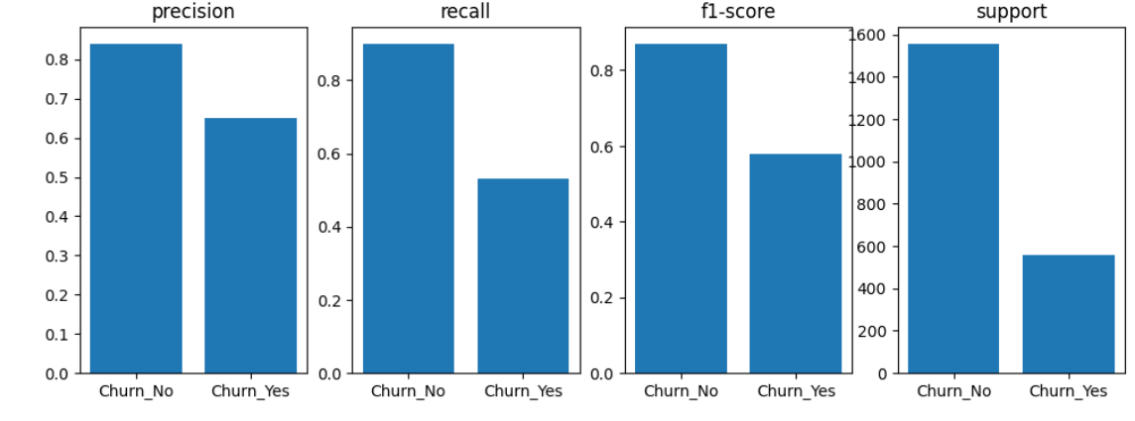
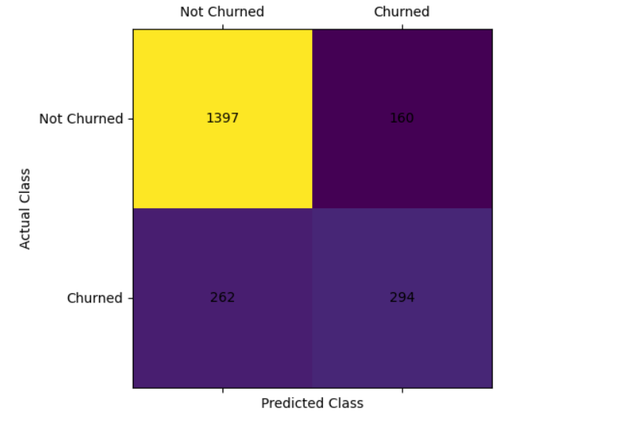
Figure:5 Prediction using Logistic Regression

5.9 Prediction using Support Vector Classifier
These data points are fed into a support vector machine, which produces the hyperplane—which is just a line in two dimensions—that best separates the tags.

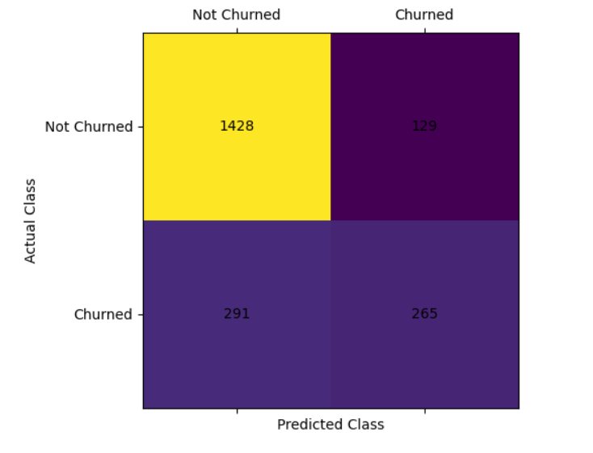
Figure:6 Prediction using Support Vector Classifier

5.10 Prediction using Decision Tree Classifier
A Decision Tree is a popular machine learning algorithm used for classification tasks. It represents a flowchart-like tree structure where each internal node represents a decision or test on a feature, each branch corresponds to an outcome of the test, and each leaf node represents a class label (in this case, churn or no-churn). Decision Trees recursively split the data into subsets based on the most informative features, making them suitable for classification tasks.
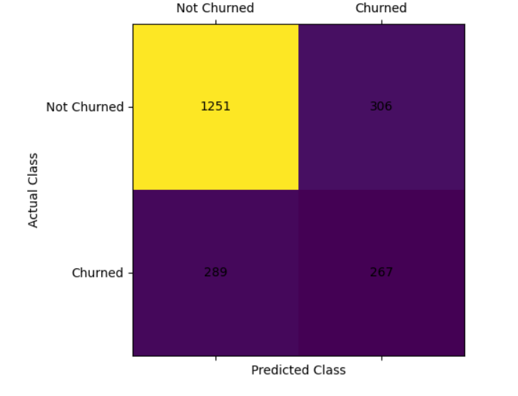
Figure:7 Prediction using Decision Tree Classifier

5.11 Prediction using KNN Classifier

KNN is a machine learning algorithm used for classification tasks. It operates on the principle of similarity, where it classifies a data point by looking at the class labels of its K nearest neighbors in the feature space. In the context of telco churn prediction, KNN assesses the similarity between a customer and their neighbors to determine if they are likely to churn or not.
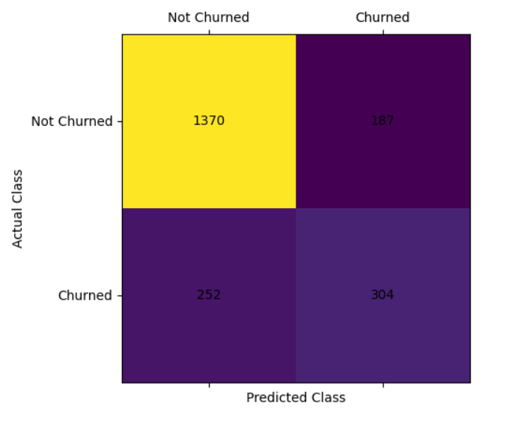
Figure:7 Prediction using KNN Classifier
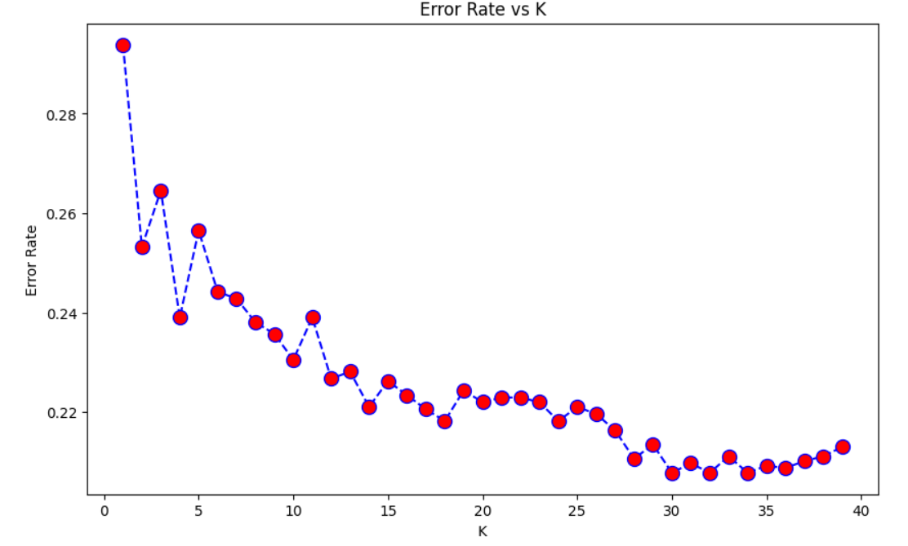
Figure 8: Error Rate

VI. CONCLUSION
Data preprocessing in telco customer churn prediction refers to the set of tasks and techniques applied to the raw telecommunications customer data before it is used for analysis or machine learning modeling. This process involves cleaning, transforming, and organizing the data to ensure it is accurate, complete, and suitable for predictive modeling. Data preprocessing aims to enhance the quality of the dataset, making it more effective for identifying patterns and predicting customer churn accurately. Common data preprocessing steps in this context include handling missing values, encoding categorical variables, scaling numerical features, and addressing outliers, among others. The ultimate goal of data preprocessing is to prepare the data so that machine learning algorithms can be applied effectively to predict customer churn and assist telecom companies in customer retention efforts.

REFERENCE
[1] V. Lazarov and M. Capota, ‘‘Churn prediction,’’ Bus. Anal. Course, TUM Comput. Sci, Technische Univ. München, Tech. Rep., 2007. [Online]. Available: http://citeseerx.ist.psu.edu/viewdoc/download? doi=10.1.1.462.7201&rep=rep1&type=pdf.
[2] S. A. Qureshi, A. S. Rehman, A. M. Qamar, A. Kamal, and A. Rehman, ‘‘Telecommunication subscribers’ churn prediction model using machine learning,’’ in Proc. 8th Int. Conf. Digit. Inf. Manage., Sep. 2013, pp. 131–136
[3] F. Castanedo, Using Deep Learning to Predict Customer Churn in a Mobile Telecommunication Network (2014)
[4] J. Hadden, A. Tiwari, R. Roy, D. Ruta, Computer assisted customer churn management: state-of-the-art and future trends. Comput. Oper. Res. 34, 2902–2917 (2007). https://doi.org/10.1016/j.cor.2005.11.007
[5] C. Kirui, L. Hong, W. Cheruiyot, H. Kirui, Predicting customer churn in mobile telephony industry using probabilistic classifiers in data mining. Int. J. Comput. Sci. Issues. 10, 165–172 (2013)
[6] S.A. Qureshi, A.S. Rehman, A.M. Qamar, A. Kamal, A. Rehman, Telecommunication subscribers’ churn prediction model using machine learning, in: 2013 Eighth International Conference on Digital Information Management (ICDIM), IEEE, 2013, pp. 131–136.
[7] Adhikary, D.D., & Gupta, D. (2021). Applying over 100 classifiers for churn prediction in telecom companies. Multimedia Tools and Applications, 80 (28), 35,123–35,144. https://doi.org/10.1007/s11042-020-09658-z.

[8] "How Costly Is Customer Churn in the Telecom Industry?", The European Business Review, Aug 2020, [online] Available: https://www.europeanbusinessreview.com/how-costly-is-customer-churn-in-the-telecom-industry/.
[9] S.A. Qureshi, A.S. Rehman, A.M. Qamar, A. Kamal, A. Rehman, Telecommunication subscribers’ churn prediction model using machine learning, in: 2013 Eighth International Conference on Digital Information Management (ICDIM), IEEE, 2013, pp. 131–136.
[10] S. Gürsoy, U. Tug˘ba, Customer churn analysis in telecommunication sector, J. School Bus. Admin. Istanbul Univ. 39 (1) (2010) 35–49.

